Views
- What is Views?
- Understanding Views versus custom code
- Configuring a view
- Query Settings
- Format
- Grid (output format)
- HTML list (output format)
- Theming a view
- Theming a single field in a Views 3 template
- Theming ajaxified view/view block
- Views video tutorials
- Views issue queue
- Bug Squad: How to work the issue queue
- Bug Squad: Additional tasks
- Bug Squad: Roster
- Views issue queue guidelines
- Views HowTos

What is Views?
Last updated on
1 December 2016
The views module allows administrators and site designers to create, manage, and display lists of content. Each list managed by the views module is known as a "view", and the output of a view is known as a "display". Displays are provided in either block or page form, and a single view may have multiple displays. Optional navigation aids, including a system path and menu item, can be set for each page-based display of a view. By default, views may be created that list content (a Nodeview type), content revisions (a Node revisions view type) or users (a User view type). A view may be restricted to members of specific user roles, and may be added, edited or deleted at the views administration page.
For more technical users, views can be understood as a user interface to compose SQL-queries, pulling information (Content, Users, etc.) from the database and showing it on screen in the desired format.
The "building block" design of the views system provides power and flexibility, allowing parameters to be specified only when needed. While an advanced view may use all of the available parameters to create complex and highly interactive applications, a simple content listing may specify only a few options. All views rely on a conceptual framework that includes:
Fields
Fields, or the individual pieces of data being displayed. Adding the fields Node: Title, Node: Type, and Node: Post date to a node view, for example, includes the title, content type and creation date in the displayed results
Relationships
Relationships, or information about how data elements relate to one another. If relationship data is available, like that provided by a CCK nodereferencefield, items from a related node may be included in the view
Arguments(D6)/Contextual filters(D7)
Arguments, or additional parameters that dynamically refine the view results, passed as part of the path. Adding an argument of Node: Type to a node view with a path of "content", for example, dynamically filters the displayed items by content type. In this example (shown with Clean URLs enabled), accessing the view through the path "http://www.example.com/content/page" displays all posts of the type "page", the path "http://www.example.com/content/story" displays all posts of the type "story", and "http://www.example.com/content" displays all posts regardless of type)
Sort criteria
Sort criteria, which determine the order of items displayed in the view results. Adding the sort criteria Node: Post date (in descending order) to a node view, for example, sorts the displayed posts in descending order by creation date
Filters
Filters, which limit items displayed in the results. Adding the filter Node: Published (and setting it equal to "Published") to a node view, for example, prevents unpublished items from being displayed
Displays
Displays, which control where the output will be seen. Every view has a default display, which doesn't actually display the view anywhere but is used to hold the default settings for the view. This default display is also used when the view is called programmatically without specifying another display. Much more useful to users are the page display, which gives a view a path and allows it to be the primary content of a page, or the block display which allows it to appear as secondary content on other pages.
Header
Header, which allow you to add by default one or more text area above the views output.
Footer
Footer, which allow you to add by default one or more text area beneath the views output.
Empty Text
The Empty Text content will be displayed, when you choose in the Arguments Section "Action to take if argument is not present" the option "Display empty text".
Parallels between the components in the Views interface and an SQL query:
SQL Query | Views Component
SELECT n.title, u.name | fields
FROM {node} n base table | view type
INNER JOIN {users} u ON n.uid = u.uid | relationship
WHERE n.status = 1 | filter
AND u.uid = arg(1) | argument
ORDER BY n.changed DESC | sort

Views

Primary tabs
- View(active tab)
- Version control
- Automated testing
91people starred this project
Posted by merlinofchaos on 25 November 2005, updated 14 April 2018

You need Views if
- You like the default front page view, but you find you want to sort it differently.
- You like the default taxonomy/term view, but you find you want to sort it differently; for example, alphabetically.
- You use /tracker, but you want to restrict it to posts of a certain type.
- You like the idea of the 'article' module, but it doesn't display articles the way you like.
- You want a way to display a block with the 5 most recent posts of some particular type.
- You want to provide 'unread forum posts'.
- You want a monthly archive similar to the typical Movable Type/Wordpress archives that displays a link to the in the form of "Month, YYYY (X)" where X is the number of posts that month, and displays them in a block. The links lead to a simple list of posts for that month.
Views can do a lot more than that, but those are some of the obvious uses of Views.

Views for Drupal 8
Views is in Drupal 8 Core!

Recommended versions of Views!
For new installs of Drupal 6, we recommend the 6.x-3.x branch. We have not changed the recommended version you see below, because there is an upgrade bug in 6.x-2.x that causes upgraded views to break. We don't want anyone getting a surprise breakage of their site.
The 6.x-2.x branch of Views is in critical/security maintenance mode only. If we can fix the upgrade issue, that will absolutely be fixed and the branch will officially be deprecated at that point. Support efforts will be concentrated on the 3.x branch.

Dependencies
The Drupal 7 version of Views requires the Chaos Tool Suite also known as CTools.

Views' bug squad
The Views' bug squad is a group of people who have dedicated a few hours a week to help provide support and fix bugs in the issue queue. They are the first line for answering questions and properly filing issues. Anyone who wishes to join the Bug Squad to help others may do so to help contribute to the Drupal community!

Views documentation
- Views 1
- Views 2 (This link goes to the Advanced Help project page. All Views documentation is included with its installation. For your convenience, you may also visit http://views-help.doc.logrus.com. This site may or may not be fully up to date at any given time.)
- Views 3 API (Generated from Views 3 source. Only useful to developers.)
- Views 3 documentation hasn't been updated completely yet. Items of note are:
  - Only UID1 can import a View.

Sponsorship
- This project is sponsored by IO1. We provide specialist consulting services in Enterprise Drupal, Views & Panels, Visit us at www.io1.biz or Contact us.

Our book
- Our book, Drupal's Building Blocks is now available. Buy it on Amazon.com.
Supporting organizations:
Mediacurrent
Ongoing maintenance support

Project information
- Minimally maintained
Maintainers monitor issues, but fast responses are not guaranteed.
- 776,370 sites report using this module
10,268,999 downloads
- Stable releases for this project are covered by the security advisory policy.
Look for the shield icon below.

As part 1 of our 3 part mini-course on Views, I've written up the notes for today's session.
Update: here is the recording
To get the most out of this mini-course, you need to know the following:
- How to customize content types (add fields); and add content in Drupal 7
- What modules are; how to install and configure modules in Drupal 7

How did you miss Views?
After Drupal 7 itself, Views is the second most popular download for Drupal. In fact, it's so popular and ubiquitous that it is now included in Drupal 8.
At least that will ensure that Drupal adopters don't miss this amazing tool.
What is surprising is that I'm still seeing client sites where Views would be a perfect fit, and yet they somehow didn't find Views yet or they don't know how it works. I've seen Drupal sites where information is copied from one page to the next to inter-link content. Oh the agony! (As I write this, I'm worried some clients might read this and think I'm talking about them. Trust me, you're not the only one!)
There are some excellent Views tutorials as well. Drupalize.me's Overview of Views is comprehensive too. And there's great documentation right within Views itself.
There's no shortage of ways you can learn how Views works.
So... how do new Drupal users keep on missing it?
The Views UI has been greatly improved, but it still offers a dizzying array of options. There are over 300 contributed modules for Drupal 7 which integrate with Views. *phew*. I think people are missing a really truly basic introduction to convince them that it's something they want to use - and that it's something they can master easily. So that is what I've set out to do.
Here's is the totally basic introduction to Views.

First things first: Views is a query builder
The first fundamental thing you need to know about Views is that it is a tool to build queries. You can even inspect the query as you build it.
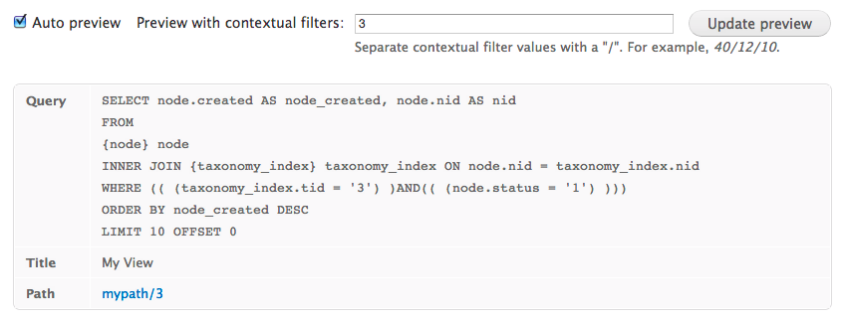
The next thing you need to understand is the UI. We find the Views initial "wizard" does confuse new learners, though it is meant to be a quick-start simplified user interface. Just keep in mind, like any good wizard, once it's done it's magic, it vanishes. The wizard allows you to select some of the settings quickly.
The Drupal Views module allows you to organize and show your content to the world in almost any way you can think of. Over half a million Drupal sites report that they use the Views module.
For instance, let's say you have a custom content type for book reviews. Each book review includes the following fields:
- Cover image
- Title
- Author
- Publisher
- Publication year
By default, Drupal will let you make a basic listing of these reviews. You can hide or show each field in the listing, and set the size of the cover image and not a whole lot else.

Mix and Match Your Content
With Views, on the other hand, you can mix and match this data into all kinds of custom listings. For instance, you could:
- Have a page that lists all books by only their title. Each title links to the full review.
- Have another page that lists all the authors you've reviewed. Each author links to a short listing of titles by that author.
- Have a third page that is only cover images, in a grid. Each image links to the full review.
- Have a sidebar that shows only the thumbnail cover image and teaser for your six most recent reviews. Further, you only show those books which are tagged with the terms "western", "mystery", or "readable Star Trek fan fiction".

Look, Ma! No Code!
You can build all these views without a single line of code.
If you had to do a view in code, it would look something like this:
SELECT node.nid AS nid,
node.created AS node_created
FROM node node
LEFT JOIN term_node term_node ON node.vid = term_node.vid
LEFT JOIN term_data term_data ON term_node.tid = term_data.tid
WHERE (node.status = 1 OR (node.uid = ***CURRENT_USER*** AND ***CURRENT_USER*** <> 0) OR ***ADMINISTER_NODES*** = 1) AND (node.promote <> 0) AND (UPPER(term_data.name) = UPPER('blog'))
ORDER BY node_created DESC
And that's just the MySQL query.

Thinking in Content Types and Views
As you learn to work with custom content types and views, you'll discover that they can solve a huge percentage of hitherto intractable CMS problems.
So often, you or your client will want "special" pages that, on other CMS software, would require complex coding, or a desperate hunt for a plugin. With a little thought, you can reduce them to one or more custom content types, and a well-built view.

Extend Views With Custom Modules
True, views can't do everything, but if you ever find yourself up against the limits of Views, check:
drupal.org
There are thousands of models that extend Views. As always, you should choose modules wisely, but it's quite possible that someone's already solved your problem.

Learn Views First
Before you go looking for a custom module, make sure you've learned what "basic" Views can do. There are plenty of tutorials out there, but the best way to learn is to enable one of the included views.

Content types
Last updated on
3 November 2016
A single web site could contain many types of content, such as informational pages, news items, polls, blog posts, real estate listings, etc. In Drupal, each item of content is called a node, and each node belongs to a single content type, which defines various default settings for nodes of that type, such as whether the node is published automatically and whether comments are permitted. (Note that in previous versions of Drupal, content types were known as node types.)
When you first install Drupal with the default installation profile (in contrast to the minimal installation profile), you will have two content types defined: "Article" and "Basic page". When you enable other core and contributed modules (by visiting Modules), you will find that you have other content types available; you can also create your own content types (see below).

Content types

Article
The Article content type (formerly, "story") is enabled in Drupal in the default installation profile. Articles are generally used for information that is updated more frequently and often cross-referenced and categorized (such as news items or resources). By default, Articles are sorted with the most recent post at the top, but this can be customized with contributed modules like Views.

Basic page
The Basic page content type is enabled in Drupal in the default installation profile. Typically Basic pages are used for static content that can (but are not required to) be linked into the main navigation bar. This is one of the most "basic" content types and can be very flexible.

Blog Entry
The Blog (short for weblog) content type was removed in Drupal 8. It is an online journal or diary, and Blog module allows registered users on your site to create their own blogs. Each entry in a user blog has content type Blog Entry.

Book Page
Book pages are designed to be part of a collaborative book, enabled by the core Book module. An example of a collaborative book is the Drupal developer documentation. In older versions of Drupal, only nodes of content type Book Page could be added to a book. However, since Drupal 7 nodes of any content type can be part of a book.

Forum topic
A Forum topic defines a topic for a forum discussion; people can reply to the topic by using comments. Forum nodes are organized into subject areas via a Taxonomy (list of categories).

Poll
A poll is a question with a set of possible responses. Once created, a poll automatically provides a simple running count of the number of votes received for each response.

Your own custom content type
You can create your own custom content types by going to Administer > Structure > Content types > Add content type. For more information on how to create your own custom content type, click here.
There are two main reasons for creating your own content type. First, content types lets you organize your site more efficiently. For instance, you might have "Info" and "News flash" as two simple content types on your site, rather than just using "Article" for both. Additionally, creating your own content type means that you can create custom fields. These fields can appear as text boxes, select lists, check boxes, etc., providing extensive functionality to content on your site.

Content types by contributed modules
Finally, contributed modules define their own content types. Check the Download & Extend/Modules page of the Drupal handbook for more information on locating an appropriate module for your needs.

About content types
Last updated 21 March 2016. Created on 29 April 2008.
Edited by joebachana, johnvsc, raelianer, jason.spradlin. Log in to edit this page.
In Drupal, a Content Type is a pre-defined collection of data types (Fields) which relate to each other by an informational context. In this sense, "context" means "parts that should be considered as a correlated whole." Content Types are how site editors can input original content on a Drupal site; while Views, for example, is one way you can serve up content to your end users.
A developer (or an administrator, with the help of CCK) can add new Content Types to collect specific information for display. Also, existing Content Types can be "extended" by adding additional Fields. Drupal 6 "ships" with two initial Content Types (Page and Story). Most commonly, "CCK" is used to add new Content Types; however, developers can define and add new types from within a "back-end" module. In Drupal 7+, "CCK" has been ingested into Drupal Core (so you don't need to add this module!)
All posts that exist on the site are instances of a content type:
Each time you create a post (page, story etc.), a content type is being used to hold and form the items you enter. When you save the post, you have created a node using a content type.
Content types need permissions too:
Goto: admin/user/permissions(Administer > User management > Permissions)
In the "node module" subsection are permissions for access content and for each content type, create, delete any, delete own, edit any, edit own, revert revisions and view revisions. These can be set by role as well.
Drupal core content types:
Drupal comes with two pre-configured default content types with different default configured behaviors. Feel free to rename, configure, change, delete as your site needs dictate.
- Page - A page, similar in form to a story, is a simple method for creating and displaying information that rarely changes, such as an "About us" section of a website. By default, a page entry does not allow visitor comments and is not featured on the site's initial home page.
- Story - A story, similar in form to a page, is ideal for creating and displaying content that informs or engages website visitors. Press releases, site announcements, and informal blog-like entries may all be created with a story entry. By default, a story entry is automatically featured on the site's initial home page, and provides the ability to post comments.
Optional Drupal core content types:
Drupal has four additional content types available when the blog, forum, book and poll modules are enabled.
To enable these, Goto: admin/build/modules/list(Administer > Site building > Modules > List) in the "core optional" subsection.
- Blog entry - A blog entry is a single post to your journal or blog. Use the full text editor with all the cool functions or choose plain text. All your blog entry's can be edited easily at any time when you Login.
- Forum topic - A forum topic is the initial post to a new discussion thread within a forum.
- Book page - A book page is a page of content, organized into a collection of related entries collectively known as a book. A book page automatically displays links to adjacent pages, providing a simple navigation system for organizing and reviewing structured content.
- Poll - A poll is a question with a set of possible responses. A poll, once created, automatically provides a simple running count of the number of votes received for each response.
Some contributed modules will create a new content type:
Many contributed modules at install time will create their own custom content type. A few examples are; Recipe, Event, Node Gallery and Web Links.
Edit an existing content type:
Content types have their own properties. To change an existing content types configuration Goto: admin/content/types/page(Administer > Content types > Page), Story, Blog -- and choose edit.
Create a new content type:
Goto: admin/content/types/add(Administer > Content management > Content types > Add content type).
Creating different or custom content types, each for a given purpose can make web site management easier and more user friendly. Each time a new content type is created, the permissions must be set for it.
Add fields, select lists, taxonomy and more to content types:
Download and install CCK(Content construction kit). Goto: admin/build/modules/list(Administer > Site building > Modules > List) in the CCK subsection; Enable content, text, option widgets and any other of the items in that section you might want use. When adding or editing a content type you will have two new tabs, Manage fields and Display Fields. Manage fields is where you add them, display fields is where you decide how they will display.
Taxonomy can also be added to any content type so the user can select a taxonomy term from a drop-down list used for classifying and arranging content.
Front page post count, teaser, and preview setting for all content types:
Goto: admin/content/node-settings(Administer > Content management > Post settings)
- Number of posts on main page: choose from the select list.
When posts exceed the number selected, a pager will display.
- Length of trimmed posts: choose from the select list.
When number of characters is exceeded, a "Read More" link will display. This also sets the length of teasers for feeds. If the setting is changed new posts will follow the setting, existing posts will remain the same. Existing posts can be edited and the teaser length can be corrected.
- Preview post: choose optional or required.

Default configuration options are as follows:
Your choices may vary depending on enabled modules.

Identification:
The information that helps identify the content type
- Name - The human-readable name of the content type.
- Type - The machine-readable name of the content type.
- Description - A description of the content type, typically entered by the site administrator. This is the text that shows on the create content page to the right of the Content Type Name.

Submission form settings:
The fields and forms available to the content type. Additional modules can add options.
- Title field label - typically Title.
- Body field label - typically Body.
- Minimum number of words - default to 0.
- Explanation or submission guidelines - typically blank but can be useful for setting user expectations towards content submission.

Workflow settings:
Default behavior for the content type. Users with the administer nodes permission will be able to override these options. Default available options are
- Published - When content is submitted, it will be publicly accessible.
- Promoted to front page - Promoted to the default Drupal front page (set to /node)
- Sticky at top of lists - Post will remain at the top of a given list. This applies to forums, the front page, a given taxonomy list.
- Create new revision - If content is edited, it will automatically save the previous version.

Working with content types and fields (Drupal 7 and later)
Last updated on
12 November 2017
In Drupal, a Content Type consists of the following primary elements:
- Content type base configuration
- Content type fields
Base configuration:
The base configuration of a content type defines the default behavior and properties of the content type. Examples include whether or not a newly created item of content has the status of published by default; or whether or not a newly created item of content is associated with one or more menus.
Moreover, the base configuration of a content type may also permit other additional custom settings provided by add-on modules.
Fields:
Content Types permit the creation of a set of fields that are associated together in some meaningful way.
Content Types are the building blocks for structured authoring in Drupal. Content types often work in conjunction with Views, which is one way you can serve up content to your end users; you can control the content types that appear and the order in which they appear. Developers can also customize the authoring experience in the same way.
One way to think of content types is to visualize the contacts on your mobile phone. If you were to duplicate this on a Drupal site you would create a Content Type. You would name your new Content Type (e.g. Contacts), define the information that you wanted to store about each contact (called Fields in Drupal), and then add those Fields (e.g. First name, last name, and mobile phone number, etc.) to that Content Type. You would then use this "Contacts" Content Type to enter the information for each of the contacts you had in your contacts list. You would use a View (as described above) to display your Contacts in a list similar to that which you see on your mobile phone.
Field terminology:
- Field. A category of data that can be added to an element, for example, Title, Body, Comment body, Tags, Image.
- Field type. The data type of a field, for example, text, integer, image.
- Field instance. A field added to an element.
"Element" above is not Drupal terminology but is used here for convenience. In Drupal terminology, this is either an entity type (such as a node or taxonomy term) or a bundle (such as an article or page).
The illustration of the Field UI below shows the field instances of the content type, Basic page. There are instances of the fields Title and Body.
An element (i.e., an entity type or bundle) can have only one instance of each field. However, a field can have a setting called "Number of values," which determines how many times a field can appear in an element. For example, if an instance of the field Image is added to the content type Basic page with "Number of values" set to 1, 3, or unlimited, then a page is allowed to have, respectively, only one, or up to three, or an unlimited number of images on it.
The primary (but not all) information about fields and field instances is stored in, respectively, the database tables "field_config" and "field_config_instance". The field type of a field is stored in the column "type" of the table "field_config". (Warning: Don't modify the structure or content of those tables (or any Drupal database tables) unless you know what you're doing. The data in those tables are connected to other data elsewhere, so changes need to be handled by the software.)

The Field UI
The Field UI module provides an administrative user interface (UI) for attaching and managing fields. Fields can be defined at the content-type level for content items and comments, at the vocabulary level for taxonomy terms, and at the site level for user accounts. Other modules may also enable fields to be defined for their data. Field types (text, image, number, etc.) are defined by modules, and collected and managed by the Field module.
The Field UI is a form used for managing fields. It comes up when you click on the Manage Fields tab of an editing form, for example, when editing a content type (such as Basic page) (/admin/structure/types/manage/page) or a taxonomy term (such as Tags) (/admin/structure/taxonomy/tags/edit). It can also be brought up by clicking on "manage fields" in the list of content types (/admin/structure/types).
The following image shows the Field UI as it appears for managing the fields of the content type Basic page:
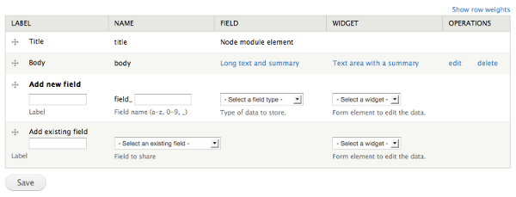
Managing fields with the Field UI
The Field UI has two parts:
- A list of field instances of the element being edited (e.g. Basic page or Tags). In the above image, the field instances are Title and Body.
- A pair of subforms for adding new field instances. These subforms are:
  - Add new field. This is used to both create a new field and to add an instance of that field to the element being edited.
  - Add existing field. This is used to add an instance of a field that already exists.
To add images or tags to a page, you use "Add existing field" because when Drupal is first installed, it predefines the fields Image and Tags.

Uses

Planning fields
There are several decisions you will need to make before defining a field for content, comments, etc.:
- What the field will be called
A field has a label (the name displayed in the user interface) and a machine name (the name used internally). The label can be changed after you create the field if needed, but the machine name cannot be changed after you have created the field. The machine name also must be unique - you cannot have two fields with the same machine name, even if they belong to different content types.
- What type of data the field will store
Each field can store one type of data (text, number, file, etc.). When you define a field, you choose a particular field type, which corresponds to the type of data you want to store. The field type cannot be changed after you have created the field.
- How the data will be entered and displayed
Each field type has one or more available "widgets" associated with it; each widget provides a mechanism for data input when you are editing (text box, select list, checkboxes, file upload, etc.). Each field type also has one or more display options, which determine how the field is displayed to site visitors. The widget and display options can be changed after you have created the field.
- How many values the field will store?
You can store one value, a specific maximum number of values, or an unlimited number of values in each field. For example, an employee identification number field might store a single number, whereas a phone number field might store multiple phone numbers. This setting can be changed after you have created the field, but if you reduce the maximum number of values after inputting/entering data, you may lose information.

Reusing fields
Once you have defined a field, you can reuse it. For example: if you define a custom image field for one content type, and you need to have an image field with the same parameters on another content type, you can add the same field to the second content type, in the Add existing field area of the user interface. You could also add this field to a taxonomy vocabulary, comments, user accounts, etc.
Some settings of a reused field are unique to each use of the field; others are shared across all places you use the field. For example, the label of a text field is unique to each use, while the setting for the number of values is shared.
There are two main reasons for reusing fields. First, reusing fields can save you time over defining new fields. Second, reusing fields also allow you to display, filter, group, and sort content together by field across content types. For example, the contributed Views module allows you to create lists and tables of content. So if you use the same field on multiple content types, you can create a View containing all of those content types together displaying that field, sorted by that field, and/or filtered by that field.
There is one main reason to not reuse a field: different permissions. For example, you may need different user roles to have different levels of access to a field, depending on the content type to which it has been added. This can be difficult if you reuse a field.
- Fields on content items
Fields on content items are defined at the content-type level, on the Manage fields tab of the content type edit page (which you can reach from the Content types page). When you define a field for a content type, each content item of that type will have that field added to it. Some fields, such as the Title and Body, are provided for you when you create a content type or are provided on content types created by your installation profile.
- Fields on taxonomy terms
Fields on taxonomy terms are defined at the taxonomy vocabulary level, on the Manage fields tab of the vocabulary edit page (which you can reach from the Taxonomy page). When you define a field for a vocabulary, each term in that vocabulary will have that field added to it. For example, you could define an image field for a vocabulary to store an icon with each term.
- Fields on user accounts
Fields on user accounts are defined on a site-wide basis on the Manage fields tab of the Account settings page. When you define a field for user accounts, each user account will have that field added to it. For example, you could add a long text field to allow users to include a biography.
- Fields on comments
Fields on comments are defined at the content-type level, on the Comment fields tab of the content type edit page (which you can reach from the Content types page). When you add a field for comments, each comment on a content item of that type will have that field added to it. For example, you could add a website field to the comments on forum posts, to allow forum commenters to add a link to their website.

Remove field
If you need to remove a field completely one would delete it from all existing content types where it exists. The Field UI can tell you what content types a field is being used on before you try and delete the field.
However, some modules create fields automatically and must be uninstalled to have their fields removed. After you disable the module, you'll have to go to the uninstall tab to complete the uninstall process.
The fields you want to delete should be deleted when cron runs, however, some people have reported that multiple cron runs are needed for the field to fully deleted depending on how much data or how many fields are being deleted at one time. Run cron several times, if your field isn't deleted right away.
A better way to do this is run these two functions:

field_delete_field($field_name); field_purge_batch(); // note: only run this if you need the field deleted immediately!! otherwise it will just be deleted the next time the cron runs
If you manually delete fields from the database, many things can go wrong. For example, hook_field_delete will not be called and one of your modules might fail and crash the site. For this reason, it is best to only use the Field UI for deleting fields if you aren't comfortable with the code or with SQL/databases.

Versions

Drupal 7
The Fields module was incorporated into Drupal 7. Unlike earlier versions, you do not need to download a separate module to add fields to a content type.

The Content Construction Kit (CCK) in Drupal 6 and lower
Field UI module is the core version of the Drupal 6 CCK module.

Technical details
Default module: Yes.
Dependencies: Field, Field SQL Storage module or custom storage module.
Related Modules: Field, Field SQL Storage, File, Image, List, Number, Node, Taxonomy, User, Text
Permissions: None.
API Documentation: Field storage API
Database tables: None.

Create a custom content type
Last updated on
27 May 2017
When creating a custom content type the first step is to set the base configuration for the content type. After that you may optionally add one or more fields.
Step by step:
- Navigate to the Content types page (Administer > Structure > Content types).
- Click Add Content Type.
- In the Name field, add a name for the content type. The name is required.
- In the Description field, you can write a description of the content type that will show up on the Add new content page (Administer > Content > Add new content). The description is not required.
- Set your preferred base configuration for this content type. Any content that you create of this content type will have these values by default. The values can be overridden for each content created. You can specify default values for Submission form settings, Publishing options, Display settings, Comment settings and Menu settings.
- Once your preferred base configuration is saved, you can either click Save content type or Save and add fields. Save Content Type leaves the content type with the Title and Body fields, while Save and Add Fields allows you to add more fields to the content type. You can always add more fields later.
- When adding fields, you have the choice to either add a new field or add an existing field. See this guide for adding fields to content types.
- Once your content type has the desired fields, you can create an instance of it as a node by navigating to the content page (Administer > Content). Then select the name of your content type.
Submission form settings
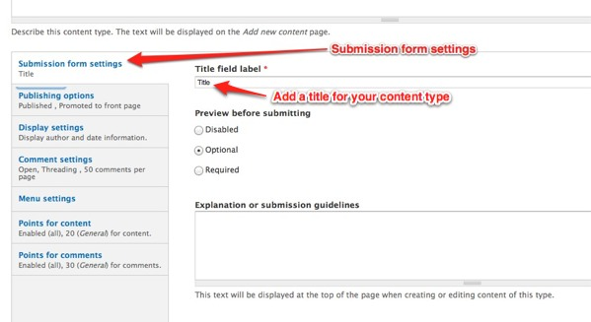
In the Title field label, you may add a title for your content type. For example, if your content type is "Furniture," you can choose a title of "Furniture Type." Note: The default for this field is "Title."
Publishing options
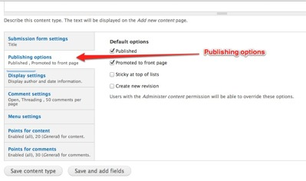
The default publishing options are Published and Promoted to front page. Additional options are available.
Display settings
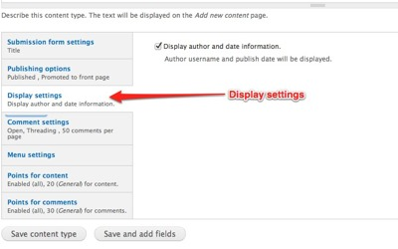
The Display Settings has one option which allows the Author username and publish date to be displayed with the content.
Comment settings
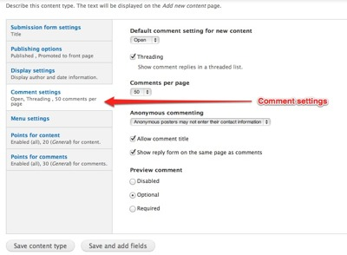
You may leave comments open, closed, or hidden. The default values allow for 50 comments to be published per page in a threaded list. If you're a beginner, you may want to keep these default values.
There is more information on the comment settings at: Administering a content type's comment settings.
Menu settings
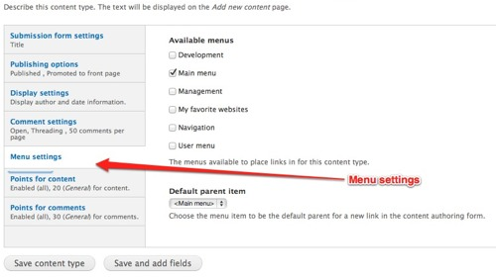
In the Menu settings you can choose which default parent item to use. This comes in handy when using taxonomy in your site.

What is a content type?
Websites contain many different types of information. Each individual set of information is called a node. A Content Type is a set of fields for a particular type of data. For example, the simplest content type is a Basic page. A Basic page has two fields - a field for the node title and second field for the body into which the node content is placed. The title and body fields display information to the user. Additional fields for a node store url and redirect settings.
In addition to the fields, certain settings are also be associated with a content type, for example, publishing options, page comment options and options for which menu will display this content type.
You can also add new content types to meet your needs. For example, suppose you were planning a meeting or conference for which people had to register. You would need to collect certain basic data about each attendee. To do so, you might create a content type with fields to capture, store and display contact information, payment information, session information, housing information, etc.
Drupal Cloud comes with several content types which are explained in the next section. Any content type may be edited by adding, deleting or modifying fields or options.

